CSA1411-COMPILER DESIGN

LAB EXPERIMENTS

NAME:- R KALAI AMUDHAN

REG NO:- 192511292

EXPERIMENT – 4:
AIM:-
To Design a lexical Analyzer to validate operators to recognize the operators +,-,*,/ using regular Arithmetic operators.
CODE:-
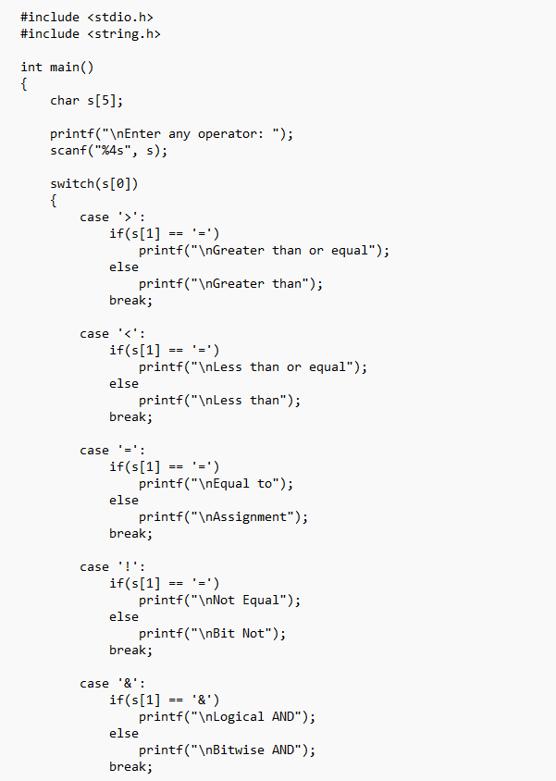

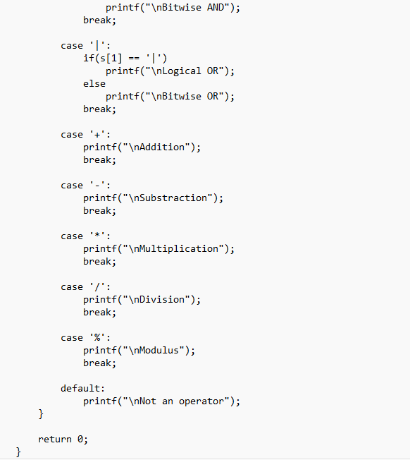

OUTPUT:-
